Drone Simulation User Manual
Jack Jiang (z5129432)

This user manual describes how to use emulating system, including how to wire up the AVR lab board. Descriptions will be given on each input action and how output displays should be interpreted.

Wire Connection
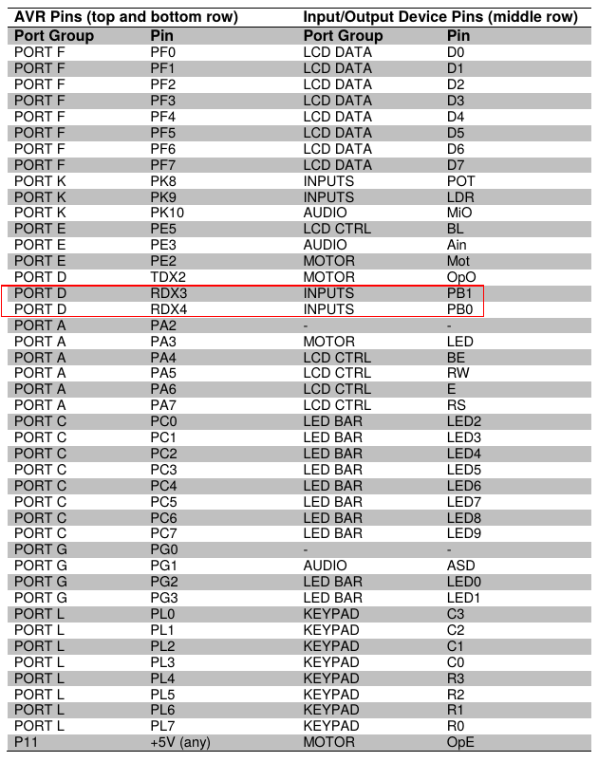

Input and output
The emulating system will word in different mode, with different input and output. This chapter will describe those input and output for different mode.

Grounded Mode
When reset the board, the system will be in Grounded Mode.

Input
Keypad:
Used to set the x-y location of the accident (x, y)
First input the location of x, which in range 0 to 63, press # to confirm
Then input the location of y, which in range 0 to 63, press # to confirm
Left Push Button:
Used to launch the search
When the button is pressed, the drone will flight to the area and start search and the system will go into Search Mode.
This button is valid only when valid accident location has been input.

Output
LCD:
Used to display Drone status: G(grounded)
and x, y of your input.
If your input is out of range, it will display OV, you need to reset the board and input again.
LED:
When the drone start off, LED will simulate a “energy charging” process.
Motor:
When the drone grounded, the motor stops.
When the drone is tarting off, the motor spins at a low speed;
When the drone flights, the motor spins at a fast speed;

Search Mode
When press left push button, system will go into Search Mode.

Input
Right Push Button:
Used to abort the search
When pressed, the drone will fly back to (0, 0) and the system will go into Aborted Mode.
When accident is found, the system will go into Aborted Mode automatically.

Output
LCD:
Used to display Drone status S(search) and Drone location: (x, y, z)
It will also display “not found” or location of the accident (x, y, z)
Motor:
When the drone flights, the motor spins at a fast speed;
When the drone find the target , it will halts in the air for a while and the motor spins at a low speed;

Aborted Mode

Input
None

Output
LCD:
Used to display Drone status A(aborted) and Drone location: (x, y, z)
It will also display “not found” or location of the accident (x, y, z)
LED:
When the drone start off, LED will simulate a “energy decreasing” process.
Motor:
When the drone flights, the motor spins at a fast speed;
When the drone is landing off, the motor spins at a low speed;
When the drone grounded, the motor stops.

